Zhuzihu Community, Taiwan
An Idyllic Farm Village in the Heart of a National Park

We at Zhuzihu were thrilled when we learned about our entry tothe International Awards for Liveable Communities 2013. Our community is steeped in history, and we are hard at work to resurrect Zhuzihu’s cultural past; and,with lessons learned, we look forward to celebrating a future of sustainable management of our community and devoted public engagement.

Zhuzihu, located in the heart of the Yangmingshan National Park, Taipei, Taiwan, is one of the island’s most popular and historied mountainside parklands.
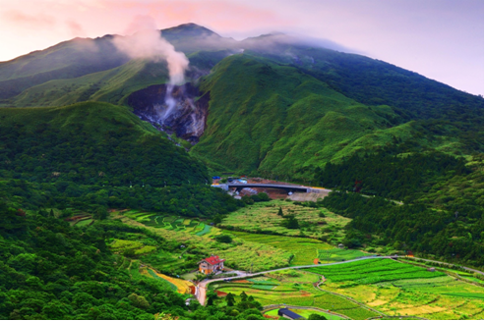
At 16,1595 square kilometers in size, Zhuzihu is a treasure cove of geological, topographical assets, lovely landscapes, plus hydrological, hot spring and wildlife riches that have helped the area sustain the financial hardships to come.
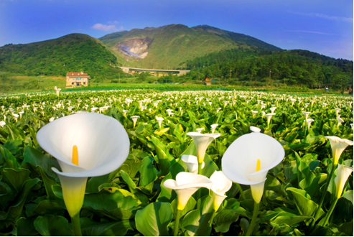
Zhuzihu consists of Dinghu, Xiahu, and Donghu hamlets and a central woodland area. It is home to a populace of a little over 1,000; annual temperature is a comfortable 18.7℃.

Heeding the lessons from a devastating 2001 flood, the residents, farmer’s co-op, the national park administration office and the city government joined hands to diversify their agricultural ventures to horticultural and leisure farming, and concentrate on giving Zhuzihu a personality. The result is an phenomenal smorgasbord of wildlife sanctuary, rehabilitation, horticultural endeavors, and environmentally-forward initiatives. Zhuzihu is now celebrated as “Taipei’s Back Garden,” where Taipei citizens visit to lap up the greatest gifts that Mother Nature has to offer.
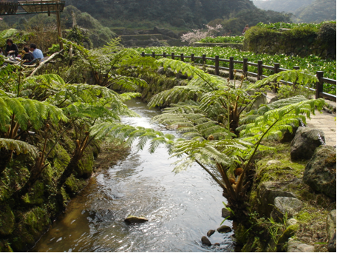
Many projects have since been launched to preserve this small patch of paradise in the mountain area. Safe passages were built to ensure an undisrupted travel space for the wilderness inhabitants. We worked closely with the City Government and the Farmer’s Co-op to rebuild the area’s ditches and gulleys following the destructive floods and typhoon in 2000 and 2001. This pleasant, environmentally-thoughtful blue network set against the emerald green mountainscape helps preserve the soil and water.
Japonica rice – once the lifeline of Zhuzihu – was phased out by other economic crops in the 19th century. In a tribute to remember this part of history, the community resurrects the rice – and the history it helped establish – on a small tract of farmland. An Exhibition Center has also been set up here on the premises dedicated to agricultural education and the legacy of the rice.

The farmland also serves as a fantastic field trip destination for local schoolchildren: shedding the cumbersome shoes, they get to dip their feet in the organically-maintained, watery mud and enjoy a lesson in rice-growing. All around them, the calla lilies – a flower that brought Zhuzihu back to life – swing gently to the giggles of the children.
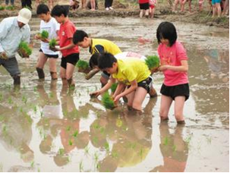
We also host a diversity of festivals to celebrate different seasons, and take advantage of the festive occasions to welcome the relatives and family members of Zhuzihu – who have moved away – back home for happy reunion.
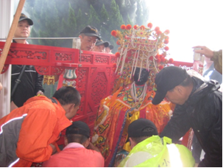
There is much to do and see in Zhuzihu, and we take great pride in what Zhuzihu has achieved after 150 years of travails and trials. We hope that this submission would open the eyes of the world to this mountainside community, and the commitment it has made to the natural environment and the future generations.
